Claude

Age 7, Cancer

“I wish have a shopping spree and fight bad guys dressed as a Red Power Ranger”

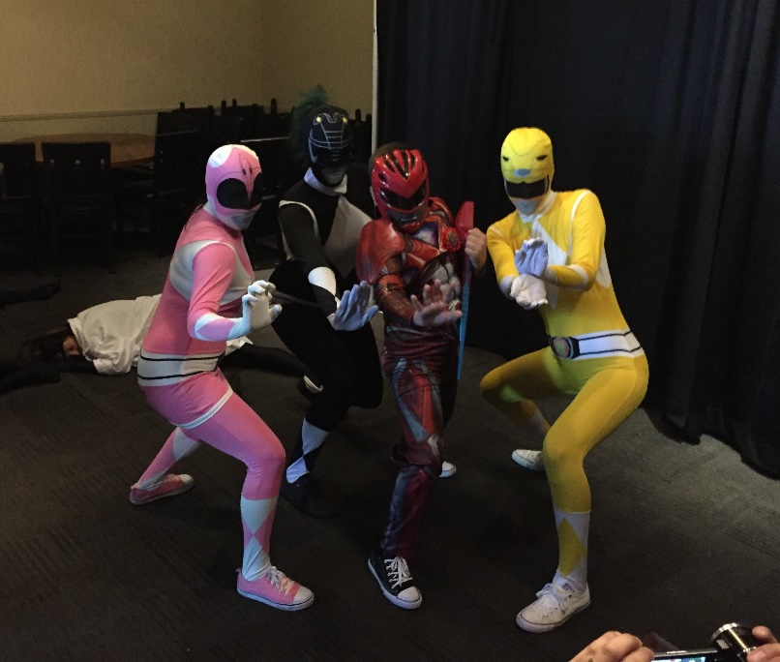
July 15, 2017
Claude is a seven year old boy who loves superheroes, but most importantly, he loves the Power Rangers. For Claude’s wish, he decided that he wanted to go on a shopping spree and fight “bad guys” while dressed as a Red Power Ranger. He always needs to protect his family whenever they are out in public and this was the perfect opportunity for him to save the day!
On July 15, 2017, a limo picked Claude, mom, dad, stepdad, grandma and sister up from his house. They went to all different stores including Toys R Us, Walmart, Target and Big Lots. It was no surprise that Claude bought a lot of Power Ranger toys and figurines. When it was finally lunch time, they headed to Dave and Busters. Little did they know, Dr. Destructo was going to be taking over Dave and Busters and Claude was going to have to battle him! Claude had to fight three different Ninja Scientists to finally get to Dr. Destructo. The other Power Rangers showed up to help Claude save the day, but they got taken under Dr. Destruco’s spell and Claude had to smash the mind-controlling device in order for the spell to stop! In the end, Claude defeated Dr. Destructo and saved the day!
Claude saved all of the citizens in Dave and Busters and was thrilled that he was able to put his Power Rangers skills to use!

